Lab 09a - Implement Web Apps

Student lab manual

Lab scenario

You need to evaluate the use of Azure Web apps for hosting Contoso’s web sites, hosted currently in the company’s on-premises data centers. The web sites are running on Windows servers using PHP runtime stack. You also need to determine how you can implement DevOps practices by leveraging Azure web apps deployment slots.

**Note:** An [**interactive lab simulation**](https://mslabs.cloudguides.com/guides/AZ-104%20Exam%20Guide%20-%20Microsoft%20Azure%20Administrator%20Exercise%2013) is available that allows you to click through this lab at your own pace. You may find slight differences between the interactive simulation and the hosted lab, but the core concepts and ideas being demonstrated are the same.

Objectives

In this lab, you will:

* Task 1: Create an Azure web app
* Task 2: Create a staging deployment slot
* Task 3: Configure web app deployment settings
* Task 4: Deploy code to the staging deployment slot
* Task 5: Swap the staging slots
* Task 6: Configure and test autoscaling of the Azure web app

#### **Task 1: Create an Azure web app**

#### **Task 2: Create a staging deployment slot**

#### **Task 4: Deploy code to the staging deployment slot**

#### **Task 6: Configure and test autoscaling of the Azure web app**

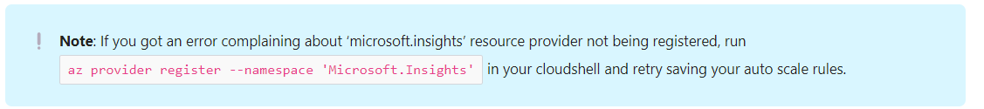

The issue in question does not seem to be fixed. The Note above was used. To resolve the issue.

Scale out successful.

